Student Name:_______________________ Lab Section:_____
/6
Marks

Due Date: Before the start of your second lab. You can’t start the next lab until this lab is fully working.

Hard Disk Preparation and O/S Installation

Materials needed before you begin
- One “caddy”: an external 3.5” Hard Drive Enclosure (e.g. NexStar) with eSATA interface (supplied by Algonquin College Technology Store), including an eSATA cable, a USB cable, and Power Supply.
- One SATA Hard Drive (200GB or larger, supplied by Algonquin College Technology Store)
- A blank CD (to create a lab boot CD – you may be able to borrow an existing CD during the lab)
- Fedora 12 DVD disk or ISO file (from your textbook or as downloaded from the CSTECH web site)

Note on the Fragility of Hard Drives in backpacks
Your hard disk is very sensitive to shock. Don't store it unpadded in the bottom of your backpack where it will hit the floor every time you drop your backpack. Keep it in a thick bubble wrap envelope or wrap it in your clothes. Store it in your locker when you aren’t using it – don’t carry it around all the time.

Procedures
Follow these procedures carefully. Read all the lab instructions (all the words) before starting. Not everything in this lab is presented in strict chronological order. Read it all, then proceed in a logical order.

Examine the Hard Drive (if it is not already installed in the enclosure)
Note the information label on the top of your hard drive indicating manufacturer and/or make of hard disk (Western Digital, Maxtor, Seagate, Quantum, etc.), model number, and capacity in gigabytes (GB) or terabytes (TB). Record this information below:

Manufacturer __________________________ Model Number ________________________

Capacity ______________________________

Assembling the eSATA hard drive enclosure (if necessary)
Before assembling the drive into the enclosure, label your hard drive with your name (see below).
For installation in the caddy, see step-by-step help at: http://cstech/eSATA.html
Remove your anti-static wrist strap and disconnect it from the computer when you are finished.

Label the Hard Drive and Caddy
It is important to label both the hard drive and caddy with your name in case you misplace or forget your drive. Many students forget their drives in labs each week; without your name, we can’t contact you.
- Before you put the lid on your caddy enclosure USE FELT PEN OR A LABEL TO PUT YOUR NAME ON THE HARD DRIVE. (Only applies if the hard drive is not already installed).
- Then, secure the lid back onto the caddy. USE A LABEL AND FELT PEN TO PUT YOUR NAME ON THE CADDY ITSELF so that we can return it to you when you leave it in a lab some day. Showing this external label to your instructor when you finish this lab is worth one of your lab marks.

How to safely power on/off your caddy and computer
How to correctly boot a machine using a caddy: Make sure the computer and caddy power buttons are both OFF before you begin. Next, with the power OFF, plug the ESATA and power wires into the caddy, then turn on the caddy, then turn on the computer and let it boot. Reverse this order to shut down. Your caddy should be the first thing you turn on and the last thing you turn off. Do *NOT* turn off your caddy before you fully and completely shut down your host Windows system and power off your computer. You may corrupt your disk if you turn off the caddy before Windows has powered down. Do *NOT* plug/unplug wires unless the caddy and computer are both turned OFF.

- Testing the Caddy Hardware
When you first power on your computer, the computer runs the Power-On Self Test (POST), also called the "bootstrap" or "boot" process. During this process, one of the options you have is to push a key to access the BIOS (Basic Input Output System) configuration. The key combination to do this is briefly displayed on the screen during the POST. (DEL is a common key to use, but your machine may differ.)

In the lab classrooms, the BIOS settings are password-locked and set to automatically detect all drives, so you do not need to push any key to configure anything. Your hard drive should be correctly detected, and you should see the manufacturer and model name very briefly displayed during the POST messages. (You might be fast enough to use the Pause key on the keyboard to pause the boot process so you can read this disk information. The display goes by very quickly.)

If, after the POST, the computer cannot find a connected disk loaded with an operating system, it will pause saying “Reboot and Select proper Boot device”. This will happen if your caddy has not yet been initialized, which is the purpose of this lab today. If you can see your hard drive information on the POST screen, and your caddy blue LED light blinks during POST, proceed on to imaging your hard disk using the lab boot CD.

Caddy Troubleshooting: If Your Caddy Doesn’t Work
If your caddy doesn't work on a particular machine in a lab (i.e. your disk drive is not visible during POST, or the blue LED light never blinks during POST to indicate access to the hard disk), follow these steps:

a) Power down and try a different ESATA cable. (Many of the lab cables are worn and intermittent.)
b) Power down and try a different caddy power supply.
c) Power down and move to a different computer. (If this works, label the computer that doesn’t work.)
d) If you are imaging your caddy using the lab boot disk, try using a different boot disk.
e) Try a USB cable instead of ESATA (but USB will be *much* slower to use than ESATA!)

If your caddy still doesn't work, take your caddy apart, unscrew, remove and re-insert the hard drive, making sure to push it firmly against the circuit board for a good connection. Screw it down firmly. Many student drives shift during term and need to be re-seated inside the caddy enclosure.

If after all these attempts, you still can't get the drive to work properly, go to a working machine or an access centre and bring up the CSTECH problem report form and submit a problem report: http://cstech/ This report will go immediately to the hardware people via pager, and if they are on duty they will come to your lab right away to help you diagnose the problem. You can also try visiting the hardware lab in T110/112, though paging through the reporting form is probably faster. You cannot return your drive or caddy to the campus store as defective until it has been signed off as defective by our hardware technicians. You must follow the above steps before you can get a replacement.

- Host operating system imaging with Windows XP
The base or “host” operating system for your caddy is Windows XP. If you have already imaged your caddy and installed the base Windows XP, skip ahead to the section GNU/Linux Installation.

Continue on to create a lab boot imaging CD and then use it to install Windows XP on your caddy drive.

Use the following instructions for creating a bootable CD and imaging your caddy hard drive. (Taken from the internal web site: http://cstech/bootdisk.htm that has other imaging methods as well.)

Creating a Lab Boot Disk (imaging CD)
Your instructor may have some pre-built lab boot CDs that you can borrow, if you don’t have a blank CD of your own. We recommend you make one of these boot CDs for your own use, just in case you need it.
The lab boot disk ISO file from the CSTECH web site is a “disk image”. The ISO must be extracted to a blank CD to work. Just copying the ISO file to the CD will not work. It must create a bootable CD.
- To create a lab boot disk, start by logging on to one of the T-building second floor Windows 7 access center PC's using your Algonquin username and password.
- Insert a blank CD into the CDROM drive.
- Go to URL http://cstech/ and browse to find the LAB BOOT DISK file. Download the ISO file to your local computer. The file name is: Lab_boot_disk.iso
- Double click the ISO file you just downloaded: Lab_boot_disk.iso
- Windows Disk Image Burner will open. (If this doesn’t happen, try other methods mentioned in the online file http://cstech/bootdisk.htm such as using Nero to burn the ISO image.)
- In the Windows Disk Image Burner window, select Verify Disk After Burning, then click Burn.
- The ISO image will be burned into the CD in about one minute and then verified, then the CD will be ejected. You now have your lab boot CD. Keep it in a CD sleeve or case to prevent scratches.

Imaging your hard drive using the lab boot CD
The lab boot disk you just made can image or re-image all or part of your caddy hard disk. It only works in T building; it will not work anywhere else. The imaging cannot be stopped half-way; it must finish completely or else your drive will be corrupted and must be re-imaged again. DO NOT USE IT ON ANY DRIVE OTHER THAN YOUR CADDY. READ THE DIRECTIONS THROUGH COMPLETELY BEFORE BEGINNING AND FOLLOW THEM CARFULLY. FAILURE TO DO SO COULD RESULT IN LOSS OF ALL YOUR FILES AND TERM WORK!. Do NOT use this boot CD in your own laptop computer!
After creating your boot disk, insert it in the CDROM of the system containing the caddy hard drive that you wish to image. Reboot the system. Once the system boots from the lab boot disk, you will see two menus:
MENU 1
The first menu is where you select the T building lab you are in while imaging the hard disk. You will be given selections to choose the lab from which you’re imaging the hard drives. Carefully select the correct lab. If you select the wrong room, the imaging will not work. Select the correct lab room, e.g. T126.
MENU 2
The second menu determines how much of your hard drive to overwrite. If you have never imaged your caddy before, choose “A” to image the whole drive, both partitions. If you have already imaged your caddy with Windows XP, choose “B” instead, so that you keep your virtual machines intact. Choose carefully!
    - "Re-image your whole drive": This option will completely re-image all of your hard disk. ALL DATA FROM ALL PARTITIONS WILL BE LOST, including all your virtual machines. Your drive will be (re-)created to have 2 partitions. The first partition will be about 20Gb in size and have Windows XP Pro installed with VMware. The second partition will use the rest of your drive and be set up to be your VMware and data partition. The SID and computer name will also be changed to new random names.
    - "Re-image only the O/S Partition": This option will re-image only the first, Windows O/S partition, leaving any other partition(s) alone. Use this option when you need to recover your Windows O/S partition without overwriting the other partition containing all your virtual machines. With this option, your data (including virtual machines) will be left intact on the second partition. The SID and computer name will also be changed to new random names. This option preserves your virtual machines.
    - "Rename Only": This option does not re-image any partitions. It only changes the SID and computer name to randomly generated ones.
    - "Abort": As the the name says, this will abort all operations. Simply remove the disk and reboot afterward. Nothing will be changed.
If when using the boot CD you find it hangs for more than a minute trying to get a DHCP address, check your workstation network wiring: Trace the blue network wire at the back of the computer and make sure it is firmly plugged into both the computer and into the desk or wall. Then reboot. (Remember that the boot CD only works in T building! It will not work at home or anywhere else in the College. T building only!)

The entire Windows XP imaging process will take 20 to 60 minutes depending on networking traffic. Get started early! After it has started, you can eject the boot CD and pass it to someone else. When it’s done, you will be prompted to restart your computer and log into Windows XP Professional. The initial password is password, which will need to be changed after you log on. Remember your password; if you forget it, you have to re-image your O/S again. You may need to reboot Windows after your first login. Do so.
Write your XP password here: ___________________________________

The Windows XP you have installed will include most necessary updates as of approximately August 2011. Windows may want to install more updates – do not install the updates during the lab, because that can take a long time. Install updates at a time when you can busy yourself with other work while the updates are proceeding. Do not spend first lab time waiting for optional updates to finish downloading and installing.
- In the Windows XP ESET window, select “Strict Protection”. You are responsible for ensuring that you have a working Anti-Virus and Anti-Spyware protection on your drive as well as installing all Windows Updates. This must be done after every re-imaging of your O/S partition.
- Put your name and contact information in the OWNER.TXT file inside your Windows XP host.
- In Windows XP go to URL http://cstech/ (NOT the open Internet, because it would be too slow) and download OpenOffice (or LibreOffice) for Windows and install it on your base Windows XP system, so that Windows can read and print the Open Office lab documents used in this course. To find the software on CSTECH, click any room in the left side-bar and look under Drivers and Downloads. Showing this Open Office (or Libre Office) installation to your instructor after you finish this lab is worth one of your lab marks.

GNU/Linux Installation
After you have Windows XP and OpenOffice installed, you can create multiple virtual machines using VMware Workstation. The next step is to create a Linux virtual machine, then install Fedora Linux into it.

Create a new Virtual Machine for Fedora Linux in VMWare
- In your Windows XP host O/S, locate and start VMware Workstation (NOTE: If you are given the option of updating to a newer version of VMware, do not do it at this time)
- Go to the VMware File menu and click New Virtual Machine or select: New Virtual Machine from the Home panel.
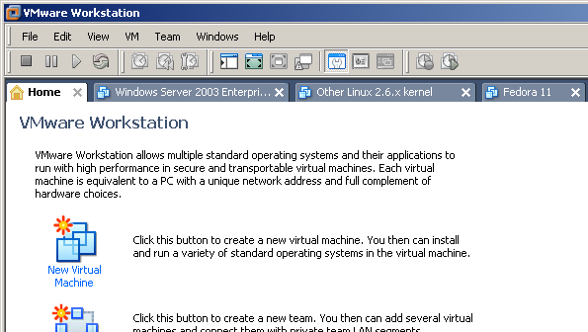

- Select Next Custom installation in the New Virtual Machine Wizard dialog window that appears then click Next.
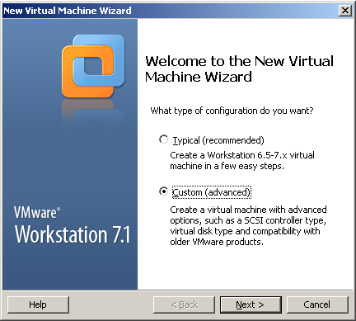

- Select Workstation 6.5-7.x from hardware compatibility list, and click Next.
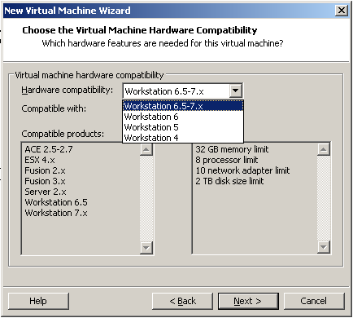

- Select I will install the operating system later and select Next.
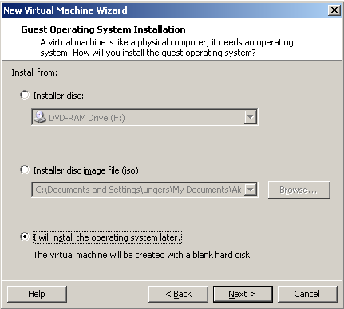

- Select Linux as the Guest operating system and chose Other Linux 2.6.x kernel and select Next.
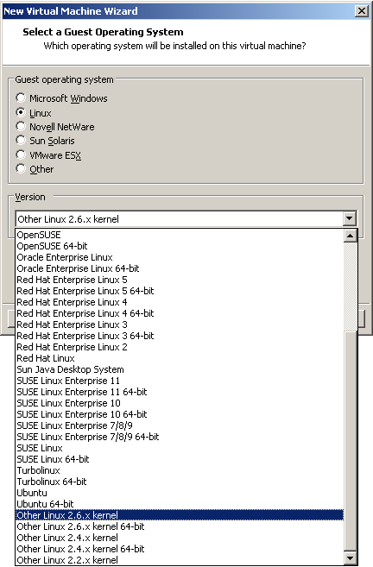

- Change the Virtual machine name (Other Linux 2.6.X kernel) to Fedora 12 and leave the Location unchanged (D:\Virtual Machines\) and click Next.
- The number of processors (and cores, if needed) should be set to One then click Next
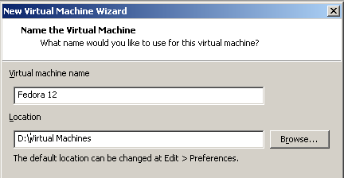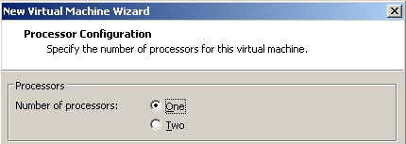

- Change the Memory to 512MB and click Next.
- Set the Network connection to NAT and click Next
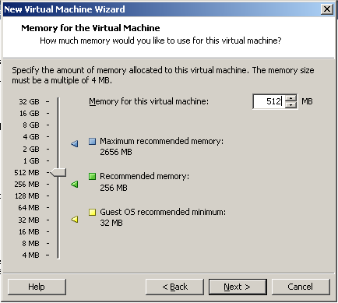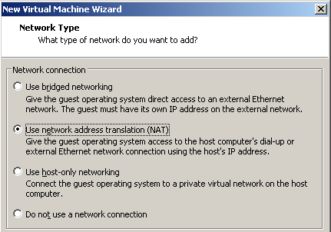

- Change (if necessary) the I/O Adapter Types dialog SCSI Adapter to LSI Logic. Click Next

- Choose Create a new virtual disk in the Select a Disk dialog and click Next.
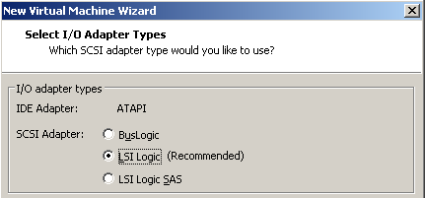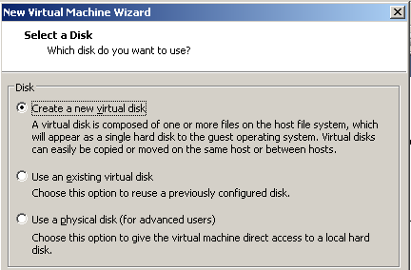
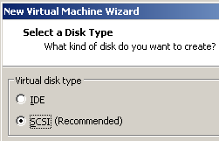

- The Disk type should remain SCSI. Click Next.

- If you are asked, the Mode “Independent” should remain un-checked. Do not check Mode “Independent”.
- In the Specify Disk Capacity dialog box: Set the Maximum disk size to 15GB. Select Store virtual disk as a single file. Do not allocate the space now. (If you allocate all disk space now, then when you copy the Virtual machine to another location or clone it, it will take a VERY long time.) Click Next.
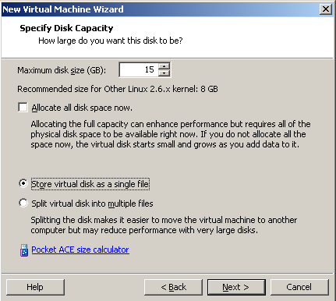
- Leave the Disk File name as Fedora 12.vmdk and click Next.
- Review the Ready to Create Virtual Machine information:
  - Name: Fedora 12
  - Location: (under Virtual Machines on your caddy D: drive)
  - Version: Workstation 6.5-7.x
  - Operating System: Other Linux 2.6.x kernel
  - Hard Disk: 15GB, Monolithic (if specified)
  - Memory: 512MB
  - Network Adapter: NAT
- Make sure your Virtual Machine has the above settings, then click Finish.
- Read carefully the Virtual Machine Created screen. It tells you what we will be doing next. The next section will install the Guest Operating System and the VMware Tools.
- Close the Virtual Machine Created dialog box.

Installing Fedora 12 – choose the ISO Method or the DVD Method
- Choose either the A: ISO Method or the B: DVD Method below. The ISO Method is likely faster and less prone to errors than trying to use a scratched physical DVD. It also lets you re-install Fedora 12 anytime without needing a physical CD. Use the ISO Method when possible.

A: ISO Method (best method):
- Download (once only) into your Windows XP host the 3GB Fedora 12 DVD ISO image from http://cstech (about 6 minutes). To find it, pick any room in the left sidebar, then look under sections such as Drivers and Downloads, Linux, Fedora, etc. Remember where you downloaded it!
- Select the Fedora 12 virtual machine in the VMware left Sidebar. Go to the Virtual Machine Settings by selecting Edit virtual machine settings or using the Settings entry under the VM menu.
- In the Virtual Machine Settings dialog box, in the left area showing all the virtual devices, click to open the virtual CD/DVD device, which will display the Device Status and Connection information for this device on the left.
- Select Use ISO image file and Browse to locate and connect the virtual CD/DVD device to the Fedora DVD .ISO image file you downloaded from CSTECH. The path to the .ISO image will appear in the box underneath the selected Use ISO image file.
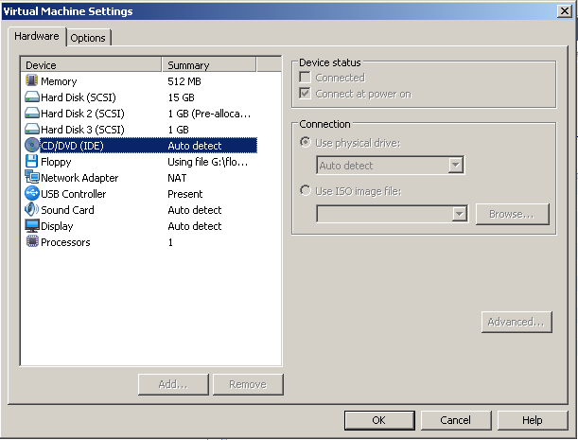

- Make sure the Device status at the top right is set to “Connect at power on”.
- Save the settings.
- Select Power On This Virtual Machine to start (boot) the virtual machine.
- Proceed to item 2 below.

B: DVD Method (not recommended):
Use this method only if the ISO Method (above) is not available.
- Insert the physical Fedora 12 DVD in the physical CD/DVD drive.
- Select “Use physical drive” in the VMware Settings for your virtual CDROM.
- Make sure the Device status is set to “Connect at power on”.
- Save the settings.
- Select Power On This Virtual Machine to start (boot) the virtual machine.
- Watch out for I/O errors from a damaged DVD! If the DVD shows any errors at all during the installation, start over with a different DVD or use the ISO Method. Do not proceed with a damaged DVD installation, even if it appears to finish correctly!
- Proceed to item 2 below.
- When you have booted the new virtual machine from the Fedora 12 ISO or the DVD, click the mouse in the Welcome to Fedora 12! window and then use the keyboard arrow keys (the mouse does not work on this initial screen) to select Install or upgrade an existing system and press ENTER:
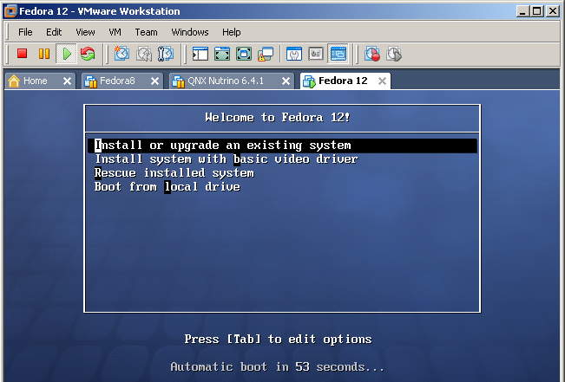

- Skip Testing the media, unless you are concerned that your DVD or ISO may be damaged.
- When the Fedora title screen appears, select Next. (There are no other options available.)
- Select the language and keyboard system: use the default English and USA settings. Click Next.
- Re-initialize the drive by selecting Re-initialize drive. (There is nothing on the new virtual disk drive yet.) This prepares the Virtual Hard Disk (which is really a virtual machine disk represented by a file) for Fedora.
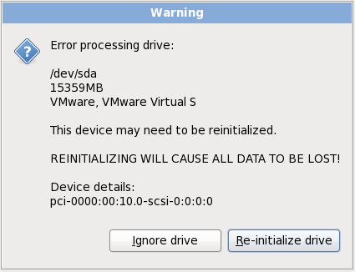
- Set the Linux Hostname to be your Algonquin College eight-character userid (your Blackboard userid), made up of part of your last name followed by some digits. Use your Blackboard userid for the name.
- Select Montreal as the closest city to our time zone, and adjust the time accordingly.
- You can select a Time/Date option to have your system time synchronized automatically from Internet time servers. Be careful about setting your machine to do this; Algonquin ITS sometimes blocks access to external network time servers. Internet time synchronization appears to work in early January 2012 when this lab was updated. Algonquin has a time server here: time.algonquincollege.com

- Create a Linux Fedora root password. Do not forget this root password! This root account serves the same purpose under Linux as your Windows XP Administrator account serves under Windows XP.
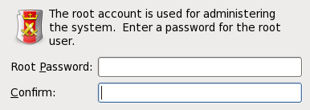

If you forget your Linux Fedora root password, you will need to restart your Linux machine in single-user or Recovery mode and create a new root password. Details for doing this are on the course web site.
Write your Linux root password here: __________________________________

- Leave the default Replace existing Linux system (even though there isn’t one) and check the Review and modify partitioning layout checkbox.
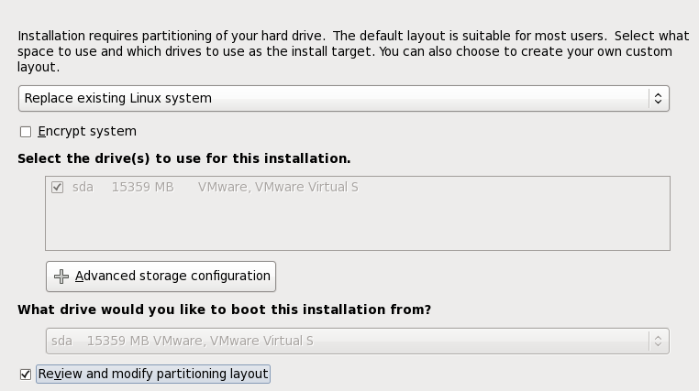

- Leave the defaults as LVM Volume Groups. (More on this in the lecture.) Click Next.
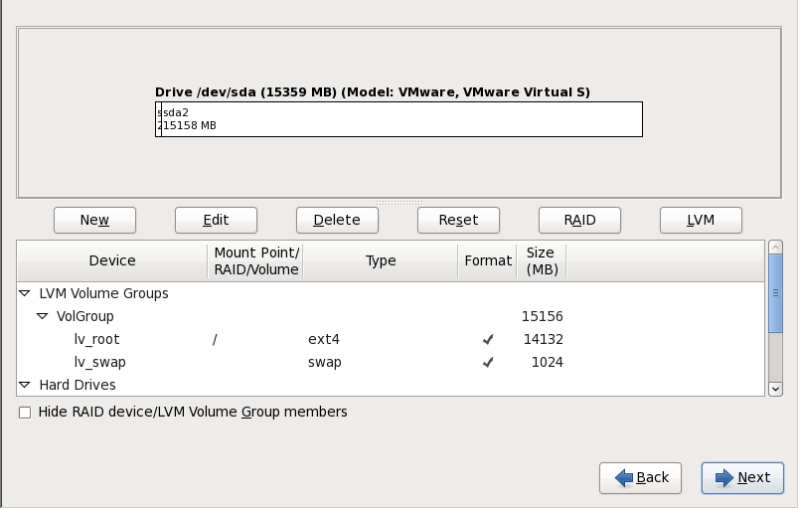

- A Format Warnings dialog will appear for the sda (first) disk. Click Format and then Write changes to disk. The formatting may take a minute or two to finish.
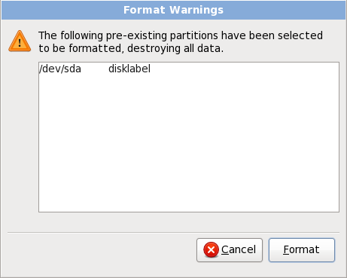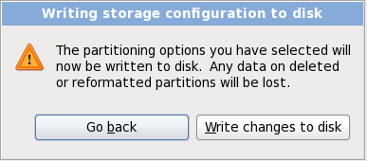
- Once the file systems have been created, you will see a Boot Loader Selection screen. Leave the “install boot loader on /dev/sda” checkbox as is selected by default and select Next.
- Select Customize Now, and click Next
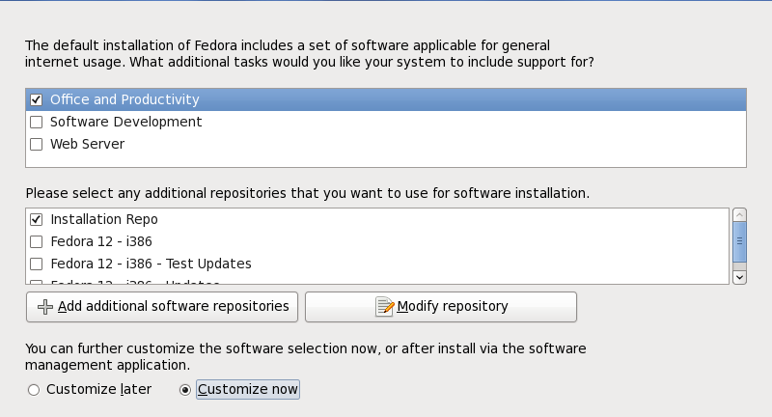
- Make sure both GNOME and KDE are selected in the group of Desktop Environments. Do not select any other software packages at this time. (You can always add more software later.) Click Next.
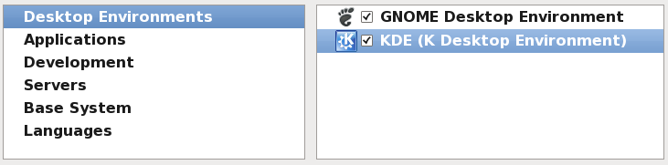
- Click Next to start the software installation, which may take 30 to 60 minutes. Wait until it finishes.
- When installation is done and you are prompted to reboot, do the following before your reboot: If you used the ISO Method, above, go to VM Settings, open again the virtual CD/DVD device, and un-check “Connect at power on”. If you used the DVD Method, remove the DVD from DVD drive.
- Select to Reboot the Fedora Linux virtual machine. (Do not reboot your Windows XP host system!)
- When the Linux virtual machine reboots from the hard drive, it will be running Fedora 12 Linux. The first time it boots, you will be asked a few questions before you can log in.
- You must create a non-administrative (regular) user account. Use your real name and your eight-character Algonquin College userid for the userid, the same userid you used for the Hostname earlier.
- Now log in to Linux Fedora using your eight-character Algonquin College (Blackboard) userid.
- If you used the ISO Method, above, go to VM Settings, open again the virtual CD/DVD device, and set the device to “Use physical drive”, then re-check “Connect at power on”. (If you used the physical DVD Method, your virtual CD/DVD is already connected to the physical drive.) Remove any CDROM.
- Once you have logged in using your Algonquin userid, ensure that you are connected to the network by selecting System eth0 or System eth1 from the network menu (dual terminal screens) in the top menu bar:
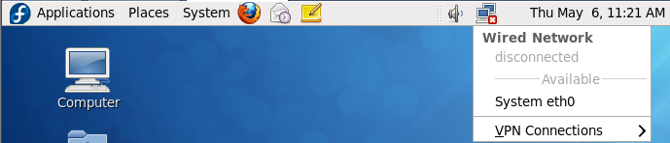

- Use the instructions at the end of this lab to configure Linux access to the printer in this room (T126). Showing the Linux configured printer at the end of the lab is worth one of your lab marks.
- Find the Terminal application in the Applications menus and drag its icon from its menu location up onto the bar at the top of your Fedora Linux window. This makes terminals easier to start.
- Open a Linux Firefox web browser (Fox icon at top) and go to the Home Page for this course.
- Find there and follow the instructions for installing VMware Tools into your Linux machine. This will let your Fedora Linux window expand to the size of your VMware window. Showing this expanded window to your instructor when you finish this lab is worth one of your lab marks.
- Use VMware to create a “Snapshot” (backup) of the current system. (VM | Snapshot | Take Snapshot) You can return to this snapshot if you have problems in later labs. Using the snapshot will save you from having to re-install the entire system. Showing this snapshot is worth one of your lab marks.
- Do not install any Fedora 12 updates – there are too many of them. Do not update Fedora 12.
- Know how to safely shut down your Linux Fedora virtual machine using the System Shut Down menu. Use the Fedora system menu to shut down Linux before you close VMware before you shut down your host Windows XP system before you power off your hard drive caddy. Knowing the correct shut-down order is worth one of your lab marks.

How to correctly shut down a VMware caddy system
Treat every virtual machine as you would a real physical computer. You must power on and power off your real and virtual systems in the correct order to avoid file system damage and locked VMware images:
- Inside VMware, shut down or pause every running virtual machine and wait until every virtual machine fully stops or pauses. Failure to do this will result in corrupted and locked virtual machines!
- Close the VMware application (after you have shut down or paused all virtual machines).
- Shut down the Windows XP host (after closing VMware) and wait until the power goes off.
- After the Windows XP host computer turns off (wait for it!), only then turn off the external caddy.
- After powering off the caddy, wait 15 seconds until the disk inside the caddy stops spinning.
- Unplug the caddy wires and pack the caddy in thick bubble wrap to take away in your backpack.
- Don't drop your backpack with your caddy inside it!

Using VMware at Home or via Laptop
You can take your caddy home (or connect it to your laptop) and plug it in as a second external hard disk, either ESATA or USB. You can then open your virtual machines from the disk and run them using either the free VMware Player (from http://vmware.com/), or the full VMware Workstation application.
The version of VMware Workstation pre-installed in your Windows XP host O/S this term is already licensed for a year. (You can renew the license via the VMware Web Store, mentioned below.) You only need a license for the second copy of VMware Workstation that you download at home (or on your laptop).
You can get an updated license for VMware Workstation by following the directions you got in a recent email message sending you to the VMware Web Store at onthehub.com. (You can also get to this store via the Drivers and Downloads menu at http://cstech/.) You do not need Workstation to run your existing virtual machines - the free VMware Player application will do that. You need a licensed copy of VMware Workstation only to modify or create new virtual machines.
For home or laptop use, use your caddy as an additional external hard disk and connect it to your existing Linux/Windows/Mac computer or laptop using an ESATA or USB cable. In most cases you won’t even need to reboot your system when you connect the external disk; the disk will be recognized when you plug it in.
Do not use your caddy drive as a boot drive (main disk) other than in the Algonquin caddy labs T108, T110, T111, T113, T114, T115, T126. Booting from the caddy anywhere else will confuse the Windows XP host operating system (because the hardware will be different), and it may lock you out and require you to re-image your O/S partition over again to recover.

Configuring the T126 Printer under Linux Fedora 12
Make sure your Networking is working before you configure a network printer. (Check the Network icon in the Linux top menu bar, and make sure you can use Linux Firefox to open a Google window inside Linux.) Installing a network printer requires network access.
Athough the printer in T126 is a Lexmark model Optera T632, the Lexmark E220 driver is available and works, so we use that below.
- Select System -> Administration -> Printing
- Under the “New” menu select Printer
- Under Devices, open Network Printer
- Under Network Printer, select LPD/LPR Host or Printer
- Put 10.50.16.249 as the Hostname (this IP address is written on the printer)
- Leave the Queue empty (blank)
- Select Forward
- In the Choose Driver dialog box, select Lexmark and then click Forward
- Under Models select Optra E220
- Under Drivers select the top (recommended) driver
- Click Forward
- In the Describe Printer dialog box shorten the Printer Name (not the Description) to lp126
- In the Location box enter: Optera T632 at 10.50.16.249 in T126
- Click Apply
- Rather than printing a test page, print something you actually need printed!
Note that the printer will only work if your Fedora Linux system is fully connected to the network, as indicated by the Network icon in the Linux top menu bar. Be careful about queueing multiple print jobs with the network disconnected - all those print jobs will rush to the printer when the network becomes active. Go to System -> Administration -> Printing and right-click on lp126 and select “View Print Queue” to see and delete queued print jobs you don’t need. Once all the print jobs go to the printer, you have to physically run to the printer and quickly use the front panel buttons to cancel all the unwanted print jobs. Save trees! Don't print!

Lab Marks – when you are finished and ready to show:
- Caddy External Label visible __________________
- Open Office installed in Windows XP __________________
- VMware Tools working (window resize) __________________
- Printer configured with correct printer name __________________
- Snapshot taken __________________
- Recite correct shut-down order __________________

